**](http://www.communitycarecorps.org/)FOR IMMEDIATE RELEASE**

**April 27, 2021**

Community Care Corps Announces New Round

of Funding to Be Available for

Volunteer Programs

Community Care Corps, in a cooperative agreement with the Administration for Community Living (ACL), is pleased to announce that funding will be available for a new round of grants. Community Care Corps will send out application information as soon as it is available.

To sign up to receive information on the next grant cycle, please go to [www.communitycarecorps.org](http://www.communitycarecorps.org) and click on “Stay Up to Date”.

Community Care Corps is a national program that fosters innovative models in which local volunteers assist with non-medical tasks, provide companionship, and relieve over-burdened family caregivers. The program offers tremendous benefit to family caregivers, older adults, and persons with disabilities.

Community Care Corps has already awarded $2.44 million to 23 innovative local programs nationwide. One hundred eighty-three organizations from 45 states plus the District of Columbia and Puerto Rico applied for funds for their programs. The 23 organizations selected serve a blend of urban, suburban, rural, frontier, and Tribal communities across the U.S. Community Care Corps looks forward to funding more projects this year.

“We are excited to be able to fund even more grants and look forward to getting applications for innovative volunteer models from local communities across the country,” said Paul Weiss, President of the Oasis Institute, which manages Community Care Corps for the Administration on Community Living.

“The Community Care Corps helps countless families and can have a lasting impact not just on the families and individuals served, but also on those who have the opportunity to serve their community as volunteers,” added John Schall, CEO of Caregiver Action Network.

Sign up now to receive more grant information when it is available. Go to [www.communitycarecorps.org](http://www.communitycarecorps.org) and click on “Stay Up to Date”.

**For more information, please contact:**

Sara Paige, [spaige@oasisnet.org](mailto:spaige@oasisnet.org) / The Oasis Institute

Derrick Goddard, [DGoddard@CaregiverAction.org](mailto:DGoddard@CaregiverAction.org) / [Caregiver Action Network](https://caregiveraction.org/)

About The Partnership Team

[](http://oasisnet.org/)

Oasisfounded in 1982,is a national nonprofit organization that is active in over 250 communities and reaches more than 50,000 individuals each year. Headquartered in St. Louis, MO, Oasis is dedicated to promoting healthy aging for older adults through lifelong learning, active lifestyles, and volunteer engagement. Oasis enables adults age 50 and over across the country to pursue vibrant, healthy, productive, and meaningful lives through in-person and online classes covering a variety of topics including arts and humanities, exercise, and more. Oasis’s flagship Intergenerational Tutoring program works in partnership with school districts across the country to pair volunteer tutors with struggling readers in grades K-3 who teachers feel would benefit from a caring, one-on-one mentoring relationship. More recently, the growing caregiving crisis has steered Oasis toward development and implementation of strategies to support caregivers, caregiver families and caregiver organizations as a part of our mission to enhance the lives of older adults.

[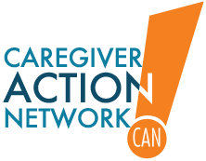](https://caregiveraction.org/)

Caregiver Action Network is the nation’s leading family caregiver organization working to improve the quality of life for more than 90 million Americans who care for loved ones with chronic conditions, disabilities, disease, or the frailties of old age. CAN serves a broad spectrum of family caregivers ranging from the parents of children with significant health needs, to the families and friends of wounded soldiers; from a young couple dealing with a diagnosis of MS, to adult children caring for parents with Alzheimer’s disease. CAN reaches caregivers on multiple platforms. CAN (the National Family Caregivers Association) is a 501(c)(3) non-profit organization providing education, peer support, and resources to family caregivers across the country free of charge.

[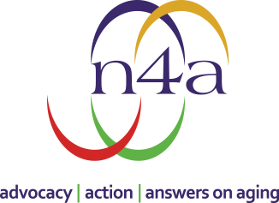](https://www.n4a.org/)

n4a is the only organization that represents the nation’s 622 Area Agencies on Aging (AAAs) and 246 Title VI Native American Aging Programs that serve millions of older adults, persons with disabilities and their caregivers. n4a is dedicated to enhancing the capacity of its members to:  advocate on behalf of older adults, persons with disabilities and their caregivers; take action to ensure that communities are equipped to support and enhance the health and well-being of older adults, persons with disabilities and their caregivers, and serve as the focal point in their community to connect people with home and community-based services.

[](https://altarum.org/)Altarum is a nonprofit research and consulting organization that serves government health insurers, health foundations, and other nonprofit clients that focus on health and healthcare. Altarum works closely with government insurance programs to conceive of and implement improvements to address the unique population health challenges of their beneficiaries. Altarum emphasizes solutions that are holistic, enabled by technology, and intently focused on prevention and appropriate care. From low-income children to frail elders, Altarum addresses the most vulnerable in society, those whose health is negatively impacted by social determinants.

[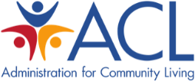](https://acl.gov/)